**P5 NPOI Capstone**

**Final Proposal**

**Bradley Kingsley**

**Dustin Haines**

**Trung Son Nguyen**

**2022-2023**

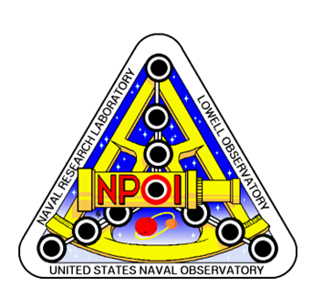

**Project Sponsor: Jim Clark**

**Instructor: Armin Eilaghi**

# DISCLAIMER

This report was prepared by students as part of a university course requirement. While considerable effort has been put into the project, it is not the work of licensed engineers and has not undergone the extensive verification that is common in the profession. The information, data, conclusions, and content of this report should not be relied on or utilized without thorough, independent testing and verification. University faculty members may have been associated with this project as advisors, sponsors, or course instructors, but as such they are not responsible for the accuracy of results or conclusions.

# EXECUTIVE SUMMARY

Many components require maintenance or repair, especially the heart of NPOI, the Fast Delay Lines (FDL). The Snoots contain custom vacuum windows allowing stellar light to enter and exit of the FDL tanks. The FDL tank Seal Plates also allow the metrology beam into and out of the tank which allows for highly accurate measurements of cart positions, on the order of a nanometer. These inner tank components from time to time must be repaired. This entails the front and/or rear seal plates to be moved/stowed and FDL tank inners worked on in an appropriate clean environment. Then all components must be reinstalled easily. Over the course of Fast Delay Line (FDL) use, there is need for periodic maintenance within the vacuum tanks confining the FDL Carts. On the front of the FDL’s there are seal plates which capture snoots to relay the light in and out of the inner room. These seal plates and snoots use many features which take long lengths of time to disassemble and assemble. This issue is apparent on the front and rear of the tanks, although the rear seal plates do not have optical pass throughs. Reducing the use of large tools (gantry crane) and quantity of technicians needed to complete this task would be most beneficial to the Opto-Mechanical Group (OMG) at NPOI. The goal of this project is to streamline these procedures to make it faster and easier to perform maintenance on the FDL’s.

There are two main aspects of the design, the front and rear seal plates, along with the snoot fixture. This plate will be light weighted but cutting out a significant portion of the unused space, to adhere to the customer need of weight. The polycarbonate windows will have an o-ring to help seal, along with a hat to fix it to the plate. The snoots will be welded onto the plate itself, while the metrology windows will be held in place by a hat that will fasten it to the plate. The rear seal plate uses the same size aluminum plate (2-in thick, 22-in diameter) and functions very similar to the front seal plate. The key difference is that the rear seal plate must have two sight ports, that allow the customer to view inside the FDL. Like the front seal plate, this plate will also be light weighted to meet the constraint of the customer. The snoot fixture involved a simpler implementation than the seal plates. The function of the snoot fixutre is to stabilize the snoots, as well as provide the ability for slight adjustments. This will be done by fixing a solid base to the existing frame at NPOI, while having a plate that the snoots will be fixed to, that will be able to move in all the required directions. The finalized CAD models are included in section 5. The simulations run in solid works proved that our design functions and adheres to the constraints of the client.

# TABLE OF CONTENTS

Contents

DISCLAIMER 1

EXECUTIVE SUMMARY 2

TABLE OF CONTENTS 3

1 BACKGROUND 1

1.1 Introduction 1

1.2 Project Description 1

2 REQUIREMENTS 3

2.1 Customer Requirements (CRs) 3

2.2 Engineering Requirements (ERs) 3

2.3 Functional Decomposition 4

2.3.1 Black Box Model 4

2.3.2 Functional Model/Work-Process Diagram/Hierarchical Task Analysis 5

2.4 House of Quality (HoQ) 6

2.5 Standards, Codes, and Regulations 6

3 Testing Procedures (TPs) 2

3.1 Testing Procedure 1: Deflection Quantification 2

3.1.1 Testing Procedure 1: Objective 2

3.1.2 Testing Procedure 1: Resources Required 2

3.1.3 Testing Procedure 1: Schedule 2

3.2 Testing Procedure 2: Leak Down Testing 2

3.2.1 Testing Procedure 2: Objective 2

3.2.2 Testing Procedure 2: Resources Required 3

3.2.3 Testing Procedure 2: Schedule 3

4 Risk Analysis and Mitigation 4

4.1 Critical Failures 4

4.1.1 Potential Critical Failure 1: Punching Shear in Seal Plate 4

4.1.2 Potential Critical Failure 2: Window O-Ring Sealing 4

4.1.3 Potential Critical Failure 3: Window Deflection to Plate 4

4.1.4 Potential Critical Failure 4: Maximum Seal Plate Deflection 4

4.1.5 Potential Critical Failure 5: Snoot Adjuster Holding Pressure Force 4

4.1.6 Potential Critical Failure 6: Snoot to Seal Plate Connection 5

4.1.7 Potential Critical Failure 7: Snoot Fixed Inside Inner Room 5

4.1.8 Potential Critical Failure 8: Seal Plate Lifting Orientation 5

4.1.9 Potential Critical Failure 9: Snoot Fixture/Adjuster Stand Strength 5

4.1.10 Potential Critical Failure 10: Front Seal Plate Eccentric Load (Snoot Plate) 5

4.2 Risks and Trade-offs Analysis 5

5 DESIGN SELECTED – First Semester 7

5.1 Design Description 7

5.2 Implementation Plan 9

6 CONCLUSIONS 12

7 REFERENCES 13

8 APPENDICES 15

8.1 Appendix A: FMEA 15

8.2 Appendix B: BOM and Budget 16

8.3 Appendix C: Schedule for Second Semester (Gantt Chart) 17

# BACKGROUND

## Introduction

The Navy Precision Optical Interferometer (NPOI) is a large astronomical observation station, created by the Navy Research Lab. The goal of NPOI is to observe faint, double, and triple stars, using the siderostat stations and use of the delay and combining lab. The 2022-2023 NPOI capstone will be based on the Fast Delay Lines (FDL), specifically the seal plates and snoots. The project includes designing rear seal plates, front seal plates with snoots, a snoot adjustment fixture, and a snoot split design. The team will design a simple rear seal plate to hold the moderate FDL vacuum, as well as integrate sight ports in the seal plate for easy inspection. The front seal plate will seal vacuum, hold the stellar and metrology snoots, and integrate view ports for easy inspection. The seal plates will also need to have a weight of 35 lbs. or less. The snoots must have an inner room fixture, allowing adjustment (pitch and yaw), as well as holding the last section of the snoot split design. The inner room section of the snoot will be stationary when accessing the front of the FDL’s. The split snoot design is a sectional tube which will be easily able to have sections removed for access in removing the front seal plate. The combination of these four objectives is to create a FDL seal plate system which one technician can assemble and disassemble with ease.

The sponsor of this project Jim Clark is interested in completing this design project because of maintenance requirements of the FDL’s, along with the need for keeping the interferometer on sky nightly. The maintenance requirements for the FDL’s are ribbon cable replacement, voice coil tuning, piezo tuning, bearing replacement, and leaf spring replacement. These maintenance items must be repaired in a quick and efficient time frame, allowing the seal plates to be less than 35 lbs., allowing any single technician the option to vent and disassemble an FDL individually. As well as removing the use of the gantry crane completely. This allows the small staff at NPOI to work on issues in parallel, instead of one at a time. Removing the gantry crane from the FDL room will also remedy the issue of tripping hazards within the FDL room, due to the gantry crane tracks. The use of the sectional snoot allows for ease of disassembly of the snoots and removes a lengthy step once fully reassembled. Alignment of the snoots will be removed using sectional snoots, this allows for the inner room section of snoot to be fixed, allowing the team to keep alignments of snoots through disassembly and reassembly. The remedy of these issues will allow the client and stakeholders to more easily maintain the FDL’s, remove safety issues in the FDL room, and reduce the number of needed alignments during FDL maintenance.

## Project Description

The following is the project description given by the Navy Precision Optical Interferometer and client Jim Clark.

The central goal of all astronomical observation is to better understand our universe and how it works. Earth and our solar system are just one possible astrophysical arrangement, so what we can learn by looking around our own neighborhood is limited. By observing the billions of other systems out there, we can develop a better understanding of what other arrangements are possible, how they might have formed, and what the implications are for potential future off-earth explorations.

Just as when you view the world with just one eye, there are limitations to viewing celestial phenomena from a single point, i.e., a traditional telescope. Observation of many 2D features benefit from combining multiple views of the target from points that are spread out spatially, a technique called interferometry. For example, the centroid of binary systems changes as one star orbits its partner, and it is the centroid of the binary system that a single telescope measures to generate a catalog of stellar positions; other applications include star-spots (which have yet to be seen!), accretion discs (as the stars spin and toss out matter of different temperature and mass), star rotations (what is the spin rate and orientation of polar axis?) and other interesting science that single telescopes simply cannot measure; we may eventually be able to use nulling interferometry for exoplanet detection.

The Navy Precision Optical Interferometer (NPOI), an astronomical long-baseline optical interferometer, has been in operation on Anderson Mesa, just outside Flagstaff, Arizona, since 1994. This facility was funded by the Naval Research Lab and the U.S. Naval Observatory and built on Forest Service land supplied using a Special Use Permit (SUP), held by Lowell Observatory. An aerial view of the site, shown in Figure 1, illustrates the general shape and layout of the 2.2-meter to 437-meter baseline array. The NPOI has a unique capacity for detecting and determining motions and orbits of binary systems. Many regional partners collaborate with NPOI to take advantage of its unique capabilities, including Northern Arizona University, New Mexico Tech, Seabrook Engineering, Tennessee State University, and Lowell Observatory.

The NPOI collects and combines light from up to six apertures simultaneously to form a high spatial resolution synthetic aperture. The wavelength range of operation is currently in the visible spectrum, 400 nanometers to 800 nanometers, and will soon include infrared wavelengths. Reconfigurability of the array generates baselines from 2.2-meters to 437-meters, and the light collected at each station is transported as a 12.7 centimeters beam through evacuated pipes to a beam combiner. Reconfiguration of the array is analogous to a zoom lens on a Digital Single-Lens Reflex (DSLR) camera.

Many components require maintenance or repair, especially the heart of NPOI, the Fast Delay Lines (FDL). The Fast Delay Lines (Figure 2), housed by vacuum tanks are used to zero the path difference, within 10’s of nanometers, from each siderostat to allow for the beams to be combined in phase. At the front of these tanks, snoots (Figure 4) are used to equalize air distances through the entire optical path. Snoots allow stellar light into the FDL’s and back out after respective reflections. The Snoots contain custom vacuum windows allowing stellar light to enter and exit of the FDL tanks. The FDL tank Seal Plates also allow the metrology beam into and out of the tank which allows for highly accurate measurements of cart positions, on the order of a nanometer. These inner tank components from time to time must be repaired. This entails the front and/or rear seal plates to be moved/stowed and FDL tank inners worked on in an appropriate clean environment. Then all components must be reinstalled easily. Presently, an overhead gantry crane and multiple technicians are required for disassembly of the FDL seal plates and snoots.

Over the course of Fast Delay Line (FDL) use, there is need for periodic maintenance within the vacuum tanks confining the FDL Carts. On the front of the FDL’s there are seal plates which capture snoots to relay the light in and out of the inner room. Figure 3 shows the snoots exiting the delay line tanks. Figure 4 shows the snoots as seen from the inner room. These seal plates and snoots use many features which take long lengths of time to disassemble and assemble. This issue is apparent on the front and rear of the tanks, although the rear seal plates do not have optical pass throughs. Reducing the use of large tools (gantry crane) and quantity of technicians needed to complete this task would be most beneficial to the Opto-Mechanical Group (OMG) at NPOI.

# REQUIREMENTS

## Customer Requirements (CRs)

In pursuit of designing a new FDL system for NPOI, many customer requirements were needed and defined by the customer. The customer requirements are listed below with weights in parenthesis.

* Lightweight (4)
* User/Technician Friendly (4)
* Seals to Vacuum (5)
* Stable Alignment (5)
* Small Deformation (3)
* Adjustable Frame (4)
* Sight Ports (2)
* Within a $9500 Budget (5)
* Durable and Robust Design (5)
* Reliable Operation (5)
* Safe to Operate in All Vacuum States (5)

The first customer requirement is for the design to be lightweight, specifically aimed at the seal plates. This requirement was issued for obtaining a seal plate which could be lifted by one person, by hand. Essentially removing the need for a gantry crane when removing the seal plates on the front and back of the FDL tanks. A weight of 4 was given due to the high desire for this plate to be lightweight. User/Technician friendly is a requirement given to ease the workload of the OMG, specifically reduce time and alignments needed for any maintenance of the FDL’s. A weight of 4 was given to this requirement because we need to ease the difficulty of the system, but this is not the main goal. Seals to Vacuum is necessary for this design due to the need to hold a moderate vacuum for extended periods of time. The weight of 5 was given because the plates must seal vacuum, there is no room for error in this requirement. When designing the seal plate, small deflection is desired, specifically we want the plate to not be visibly deformed. This is required for safety of the seal plate and comfort of use of the plate, this was weighted a 3. The weight of 3 was given because if we accomplish the other goals and this requirement is not fully complete, it may be slightly neglected by the client. The snoot adjustable frame was required because the design needs a fixture which can hold the snoots in alignment over time. A weight of 4 was given because this is a specific sub-section that must be accomplished. Sight ports were required by the customer because the need for internal inspection while the system is under vacuum, is needed. A weight of 2 was given to this because they are not absolutely needed by the client, but it would be a good addition. The budget for this project is $9500, this must be strictly used, with no additional funding, thus the weight of 5. The requirement for durable, robust, and reliable operation of the design is given a weight of 5, this is because the design must handle many assembly cycles, movements of pieces and possible issues. The system must also be totally safe to operate at all vacuum states (1mTorr and ATM), the weight of 5 was given because the system must be safe to be around at any state. The definitions of our customer requirements will help produce the engineering requirements with specified units associated.

## Engineering Requirements (ERs)

To define more specific parameters of the design, using the customer requirements, engineering requirements were created for quantifying the customer requirements. Each engineering requirement is paired with a unit to indicate how the requirement will be measured. Below if the engineering requirements for the NPOI Capstone.

* Less than 35 lbs.
* Disassembly in less than 1 hour
* Seals tanks at ATM (760 Torr) and Vacuum (1mTorr)
* X and Y Adjustment of ±0.5in
* Deformation less than 0.010”
* Drift less than 0.001 in/month
* At least 2 sight ports

The engineering requirement of less than 35 lbs. are specified for the front and rear seal plates. This requirement ensures that a single technician can remove the seal plate by hand, removing the use of the gantry crane. Disassembly within less than one hour is specified to ease the workload of the technicians, allowing for more tanks to be opened within a single day. The seal plates must also seal the FDL tanks in ATM and in vacuum, this specifies that the tanks will hold the inner contents under any condition. The snoots must be adjustable to ±0.5 in due to the need for fine alignments of the snoots if any beam is clipped on any hardware. The seal plates must have a deformation of less than 0.010” because the plates must be strong enough to hold the external atmospheric pressure, and if larger deflections are happening fatigue might be worth investigating. The drift of the snoots must be less than 0.001 in/month because alignments of the snoots should not have to happen often, other than when they are bumped, or a stable temperature issue arises. The use of 2 or more sight ports within the seal plates allows for easy viewing on the FDL internals for issues or mechanical snags. These ports allow for the tanks to not be vented in order to view the FDL inners, saving time and work for the OMG. Reliability and durability of the system are tied to deformation and sealing to vacuum, because the reliability to seal to vacuum is based on if the plates can seal at ATM and vacuum. Along with the need for the design to be durable, the deformation must be small to not induce fatigue into the design. These engineering requirements will direct the team on how the design will be geometrically built and defined for the customer needs.

## Functional Decomposition

### Black Box Model

A black box model is a simple diagram which shows how a system has specific input and output, but does not show the inner workings of how this system will work. Specifically what signal, energy, and material will be input and output from the system. Figure 1: Black Box Model, shows the model for the P5 NPOI Capstone.

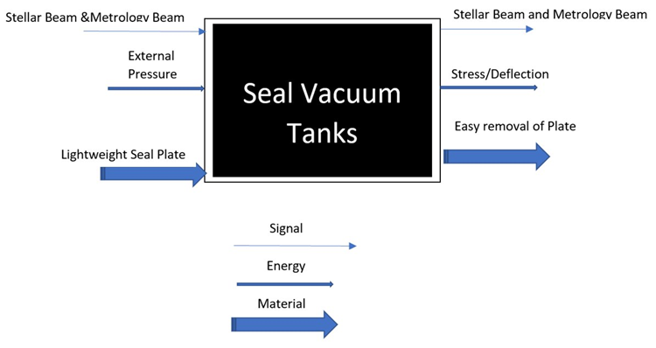

Fig 1 - Black Box Model

The inputs for the system are defined as stellar/metrology beams, external pressure, and lightweight seal plate. The beams being input are the beams which must pass through the seal plate, through a vacuum window, allowing the light to be reflected at the FDL cart. External pressure is also the input because external pressure will put force on the seal plate, specifically strain energy. The seal plate being lightweight is also an input, this is because the plate must be light to be able to be installed by hand. The signal output is the metrology/stellar beams, these beams act as the signal for the system because without these there would be no interferometry. The output of energy is stress and deflection of the seal plate, the input pressure has a direct cause for stress and deflection. The output for material is the seal plate must be easy to remove, allowing the material to be moved easily.

This black box model allows the team to simplify the system to only needed components and shows the team how the system works. This model shows all the absolutely needed components in the system, specifically the seal plate with windows allowing signal through and how the seal plate reacts with nature and humans. This model also shows the team how the system works in a very general sense, Allowing for concepts to be generated that easily incorporate the needed inputs and outputs, ensuring the needed features for functionality are included in each design.

### Functional Model/Work-Process Diagram/Hierarchical Task Analysis

The functional model is used to show the specific functions of a specified part or design. Specifically creating a flow diagram of how the part will work with more specifics, that are nt shown in the black box model. The team created a functional model of the front seal plate to analyze, being what functions does the seal plate have and what is specifically needed for the design. The front seal plate function model is presented in figure 2.

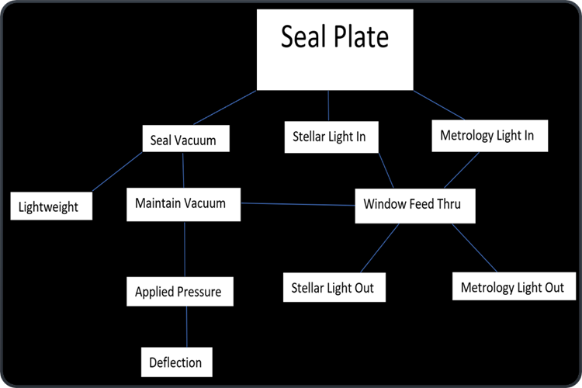

Fig 2 - Functional Decomposition Model

The functional model shown for the front seal plate shows 3 main functions with a few sub functions that are essential for success of the design. The seal plate will allow stellar and metrology light in and out, using vacuum windows for each input or output beam. This specifies the plate must have transparent windows sealed to the plate which can allow laser and stellar light to pass in and out of the FDL tank. The need for the plate to seal to vacuum is essential to success of the design, this is tied with lightweight and maintains vacuum. Although the seal plate will be lightweight (>35 lbs.), it must maintain a vacuum without issue, even if most of the plate weight is removed strategically for weight reduction. The applied pressure and deflection also correlated with maintaining a vacuum, when the seal plate gets deformed by pressure, the specified O-ring geometry might change. This shows the need for advanced finite element analysis (FEA) to ensure the seals do not leak when the plate deforms. The decomposition models give the group a simple chart to follow to ensure all the needed geometry and pass through will be included and will work properly, even with changes from ATM to vacuum.

## House of Quality (HoQ)

The house or quality (HoQ) was used by the team to relate the requirements and weights to what specific will be most important/correlated to the overall design. The HoQ is shown in figure 2. Customer and engineering requirements were inserted, and weights were associated with each to define what portions are most important to least important. The team used the HoQ in the concept generation and evaluation stages to specify if the concepts will be accomplishing these requirements or if they fall short. Three separate systems were reviewed for the HoQ, and the customer was asked to complete the survey on the systems. The client stated since the system is so specific to the site, these separate systems relate in a very small way, yet the survey was completed to the best ability. This allows the team to view other systems that may have a small amount of relation that could be used in the design. The HoQ was beneficial when generating concepts and evaluating the concepts.

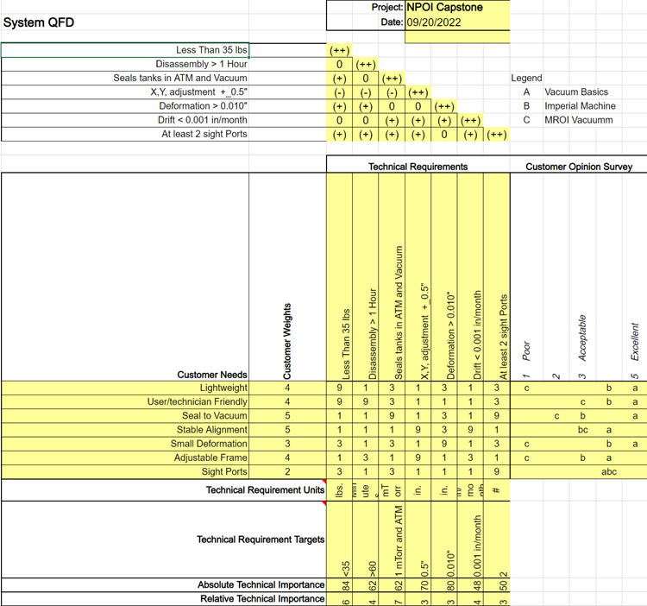

Fig. 3 - House of Quality

## Standards, Codes, and Regulations

The team must adhere to specific codes within the fabrication and engineering world in order to be able to specify properties, callout welds for vacuum application, and create drawings which are in common layouts. Shown in table 1, the codes which must be adhered to and looked up for proper use. ASTM B209-14 is a material standard that relies on the manufacturer to specify that the code is upheld in the process. This code allows for the team to indicate material properties that will be used for finite element analysis, allowing a more accurate simulation. The ASME Y14 standard allows the team to create drawings with various forms of dimension so the part will be made to our design. The standard allows for specific callout for geometric dimensioning, allowing the team to more precisely dimension the shop drawings. The AWS D17.1 code allows for the team to callout the specific welds needed for vacuum application, without worry of failure of the vacuum seal. This specification ensures that the welds designed will conform to vacuum/aerospace standards, allowing the welds to be used for the specific vacuum application.

Table I: Standards of Practice as Applied to this Project

|  |  |  |
| --- | --- | --- |
| **Standard Number or Code** | **Title of Standard** | **How it applies to Project** |
| ASTM B209-14 | Standard Specifications for Aluminum and Aluminum Alloy Sheet and Plate | The material received for the Seal Plates conforms to this standard in all respects. Allows the Team to apply material properties for analysis without worry of severe material imperfections. |
| ASME Y14 | Y14 Standards | Drawing packages are similar in nature in the direction of dimensions and layout. This allows the team to use GD&T and basic tolerancing to create part drawings effectively. |
| AWS D17.1 | AWS D17.1/D17.1M:2017-AMD1 | The welding specification for fusion welding for aerospace applications. This related the welding process that may be used to attach the snoots to the front seal plate. The welds must conform to this standard due to the vacuum application. |

# Testing Procedures (TPs)

The testing procedures outlined within this section are developed to determine if customer requirements of seals to vacuum and small deformation. These are quantified by defining deformation as under 0.010” and sealing to vacuum at ATM and vacuum at 10 mTorr. Testing these specific requirements allows for the team to verify models and ensure the vacuum will not have to be pumped daily.

## Testing Procedure 1: Deflection Quantification

The seal plates are designed such that they will deform to a specified amount when under vacuum pressure. This deflection has been quantified using SolidWorks and ANSYS simulations but will want to be verified in use. The maximum deflection on the seal plates must be 0.010” or less, this engineering requirement ensures the plate seals to the O-Rings and ensures safety of the part. Once the plate has been assembled on the FDL tank, a dial indicator will be used to test 4 positions of the plate for deflection.

### Testing Procedure 1: Objective

The test will be set up using 4 dial indicators and seal plate at atmospheric pressure within the FDL tanks. An indicator will be setup to zero after initially installing the seal plate. The indicators will be placed at the center, 2 edges perpendicular to each other, and one set on an inner pocket. The Vacuum pumps will then pull vacuum on the FDL tanks, the dial indicators will be recorded at every 30-minute interval and will be recorded with the current pressure. Once a final vacuum pressure of below 30 mTorr is achieved, the values will be recorded as full vacuum pressure deflection. This test determines the deflection of the seal plates at various locations, this will be used for a final verification of the seal plate finite model analysis. Comparing the results to the finite model, the team will deduce if the model was like real life, and what could have been changed to improve accuracy.

### Testing Procedure 1: Resources Required

In order to complete this test, the capstone team will need 4 dial indicators, 4 indicator magnetic stands, a notebook for data recording, the team, a vacuum pump for pulling vacuum, and the FDL tanks with seal plates. These tools and personnel are needed to ensure the test runs smoothly and reduce the possibility of human errors.

### Testing Procedure 1: Schedule

This test will take a full 8-hour workday to complete, due to the need to vent the vacuum system and then pull vacuum again. This test will be set up and completed after the seal plates are delivered fully machined to the NPOI site, although an intense cleaning of the seal plate will be done to ensure no outgassing of surface greases will occur.

## Testing Procedure 2: Leak Down Testing

The objective of the leak down test is to determine if the O-Rings used in the plates are sealing properly and are not allowing air to pass through into the vacuum tank. We will be directly testing if the deflections on the plate during vacuum pressure application will allow the O-rings to leak and to determine if the O-ring gland design is verified for the application. The FDL tanks will be pulled into vacuum to normal operating range, then left idle for a few days, the values on the gauges will be read and recorded. If a leak is apparent, the team will fix the issue. If no leaks are apparent, the team has successfully completed the customer requirement of sealing to vacuum.

### Testing Procedure 2: Objective

The objective of the leak down test is to determine if the O-Rings used in the plates are sealing properly and are not allowing air to pass through into the vacuum tank. The team will fully assemble the 6 FDL seal plates on the front and rear of the tanks, along with installing the snoots and fixture/adjuster. The team will then start pulling vacuum on the FDL tanks using the roots blower, the rotary vane, and turbo molecular pumps, in order of rough pumping to fine pumping. The team will record a base value of normal operating pressure, between 10-60 mTorr. The team will then check and record the values of pressure from each tank each day. Recording 6 values per day, for a total of 7 days. The data will then be reduced to determine the leak down rate and to determine if it is acceptable to the client.

### Testing Procedure 2: Resources Required

The resources required to complete this test are extensive and very detailed. The team will need all final machined parts on hand, all 3 types of pumps (on-site), the FDL tanks (1-6), and vacuum gauges that are calibrated to read accurately during moderate vacuum (10-100 mTorr). The team will use the tools and gauges onsite of NPOI for the test and will be calibrating 6 gauges for vacuum pressure.

### Testing Procedure 2: Schedule

The testing schedule will be once all parts are onsite and approved for use, the team will plan with NPOI staff to determine a good week to take down the FDL tanks for testing. Once a week has been found, the team will take 2-3 days to fully disassemble and reassembly the new FDL components. The team will then take one day to pull the vacuum and start the test. After the vacuum is pulled a vacuum pressure will be recorded as a base. Each day after the team will record the pressure and time of recording. After 7 days of testing, the data will be reduced, and assumptions made. The tanks will then be in vacuum and will be ready for use, if the test is concluded to be approved.

# Risk Analysis and Mitigation

This section will cover different critical failure factors that the team may encounter during the project. The section will explain how the failure occurs, the bad effect of the failure toward the project and what action the team would take to reduce the effect of critical failures. The full FMEA is included in Appendix A. Due to the nature of the project, there are few parts, which results in a smaller FMEA

## Critical Failures

### Potential Critical Failure 1: Punching Shear in Seal Plate

A possible failure in the rear seal plates is if the pocketing is too deep, the thin sections will be acting as if they were to punch through the plate. This failure will be caused by a thin section normal to the pressure vector, allowing for large stresses at corners, causing punching shear. This failure would fully destroy the FDL system and must be fully mitigated to ensure the safety of personnel and the site instruments. This failure can be mitigated by calculating punching shear, to ensure the plate thin sections are properly designed to hold the vacuum pressure.

[Provide a brief description of the potential failure here, how that failure could be caused, the effect of the failure, and then discuss how the failure can be mitigated.]

### Potential Critical Failure 2: Window O-Ring Sealing

A possible failure of the window O-ring could occur during deformation of the seal plate. Due to external pressure deforming the seal plate, the window spot faces will experience a deformation that is non-uniform over the spot face. This could cause issues within the O-ring seal, causing less ring compression, in turn possibly allowing leakage. This risk can be mitigated in two ways, simulation checks and window hats. The simulation check will verify if over the full spot face area, if a delta occurs greater than 0.001”. By checking the largest and smallest deformation, the delta can be found to be under 0.001” The window hat addition also mitigates risk due to the hat helping deform the polycarbonate window to the deformed seal plate. Allowing extra force to form the window to the seal plate as it is deforming. This possible failure has great possibility, but with adequate verification, it can be fully mitigated.

### Potential Critical Failure 3: Window Deflection to Plate

The window deflection in relation to the seal plate has a possibility of failure due to the window being a material that is softer than aluminum. If the window deforms more than it is supposed to, the window will begin to cup. If the window cups, there is risk of possible vacuum failure. The failure could be minimal being the window only leaks slightly, or it could pull the window into the tanks destroying the FDL internals. This risk will be mitigated by ensuring the window thickness has a large safety factor and that the spot face is large enough to bound the window. The detail of designing small plastic parts for vacuum requires extreme detail and attention to all factors.

### Potential Critical Failure 4: Maximum Seal Plate Deflection

The seal plate deflection has been defined under engineering requirements as less than 0.010”. This value was decided upon due to the need for a safe seal plate which can handle external loads other than atmospheric pressure. This ensures safety if any accident could occur where the plate will experience greater total force. The seal plate must hold 14.7 psi over an area of 201 in^2, totaling to about 3000 lbf. Any additional force could rupture thin sections, so if the deflection is less than 0.010”, it was determined that the plate is safe for extra load that still allows for the material stress to be under yielding. The verification will happen during the simulations, adding external forces of 100lbf to determine extra loading stress and deformation.

### Potential Critical Failure 5: Snoot Adjuster Holding Pressure Force

The snoot adjusting-holder that has been using at the moment at the station did not provide the ability to withstand the vacuum force and let the snoot to be sucked toward the fast delay line tank. In order to prevent the snoot from being sucked inside the fast delay line, the current front seal plate acted as the main support that stopped the snoot from entering the tank, therefore the weight of the current front seal plate was big as it needed to be tough enough to withstand all the vacuum force in the z-direction. The new snoot adjuster must be able to hold the snoot in place during standby and vacuum mode while being able to withstand the vacuum force that would apply on z-direction. The failure could be the hold could not stand still during the vacuum operation or the shear stress between the adjuster and the snoot would be too big that the adjuster could not hold the snoot properly. If the failure happens, the snoot will be sucked inside the tank and cause great damage to the tank. By adjusting the snoot to be fixed with the adjuster and build a sturdy hold, the team can minimize the shear stress effect and the hold can withstand the vacuum force.

### Potential Critical Failure 6: Snoot to Seal Plate Connection

The connection between the snoot and seal plate can have possible failure if the snoot does not properly fix on the front seal plate. As mentioned in section 4.1.5, if the snoot adjuster cannot absorb the vacuum force, then that force will apply to the front seal plate. With the new front seal plate to be less than 35 lbs., it does not have the ability to withstand the vacuum force anymore. When the failure happens, the snoot that is connected to the front seal plate can be sucked inside the tank and cause damage to the tank. That is why to minimize the failure, the team needs to make sure that there would be no extra force acting on the seal plate connection.

### Potential Critical Failure 7: Snoot Fixed Inside Inner Room

The potential failure of snoot fixed inside the inner room is the snoot cannot be adjusted to match with the stellar and metrology beams. This is because the snoot adjuster does not work as expected. To minimize failure, the snoot inside the inner room needs to be adjusted to match with the beam light through the snoot adjuster.

### Potential Critical Failure 8: Seal Plate Lifting Orientation

The new seal plate would be less than 35 lbs, however, during the assemble/disassembly process, the person who is in charge would still find it difficult to do the process alone. The seal plate must be held in line with the tank and screwed to fix with the tank. The potential failure is the shear between the seal plate with the tank during screwing. The person could feel heavy when lifting and holding the seal plate during that process and may slip it. To prevent it from happening, the team would get the screw pattern out so that the seal plate can just be put straight in.

### Potential Critical Failure 9: Snoot Fixture/Adjuster Stand Strength

The requirement for the snoot stand is the ability to withstand the vacuum force. Therefore, the snoot stand has to be sturdy and strong enough to hold the snoot from being sucked inside the tank. The failure may be stand is not strong enough and collapse with the wall. To minimize the effect, the team can add more weight to the stand to make it sturdier.

### Potential Critical Failure 10: Front Seal Plate Eccentric Load (Snoot Plate)

The snoot is not placed in the center of the front seal plate, so during vacuum operation, the snoot can apply to the front seal plate eccentric load. This could cause the seal plate to show deformation. To minimize the failure effect, the team can minimize the load that would apply to the front seal plate in order to prevent it from deformation.

## Risks and Trade-offs Analysis

The systems in critical failure show similarity. The main potential failures are the stress, shear and deflection problems. Therefore, there would be no trade-off when trying to mitigate one failure. To prevent the deflection and load applied on the front seal plate, the snoot adjuster/holder would work as the main support, which would carry all the vacuum force and prevent any extra force on z-direction to be applied on the front seal plate. The seal plate needs to be able to prevent deformation during vacuum process and stop the snoot from being sucked inside the tank. Moreover, there would be additional bolt pattern on the tank so that the person who is doing assembly/disassembly process can work easily without worrying about the shear stress effect between the seal plates with the tank.

# DESIGN SELECTED – First Semester

The first semester of the project consisted primarily of concept generation and evaluation. This led us to a prototype that will be effective in satisfying the customer's needs as well as being simple to implement. The following section reflects on the current design as well as the plan to construct that design.

## Design Description

There are two main aspects of the design, the front and rear seal plates, along with the snoot fixture. For the front seal plate, we will be using a 2-inch thick, aluminum plate that will be machined to a diameter of 22 inches. This plate will be light weighted, but cutting out a significant portion of the unused space, to adhere to the customer need of weight. This plate will have 4 holes, two for snoot fixture, and two for metrology window. The polycarbonate windows will have an O-ring to help seal, along with a hat to fix it to the plate. The snoots will be welded onto the plate itself, while the metrology windows will be held in place by a hat that will fasten it to the plate. The plate itself will be fasted to the FDL flange with 6 bolts around the outer edge of the circle. Figure 4 shows the CAD drawing of the front seal plate.

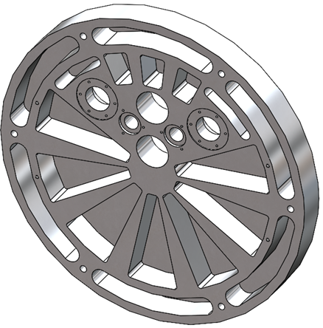

Fig. 4 - Front Seal Plate

The rear seal plate uses the same size aluminum plate (2-in thick, 22-in diameter) and functions very similar to the front seal plate. The key difference is that the rear seal plate must have two sight ports, that allow the customer to view inside the FDL. Like the front seal plate, this plate will also be light weighted to meet the constraint of the customer. The polycarbonate windows will have an O-ring to help seal, along with a hat to fix it to the plate. This plate also has a slight cutout to accommodate for the cart inside the FDL sticking slightly out. The rear seal plate will be fixed to the flange in the same manner as the previous plate. Fig 5 shows the CAD for the rear seal plate.

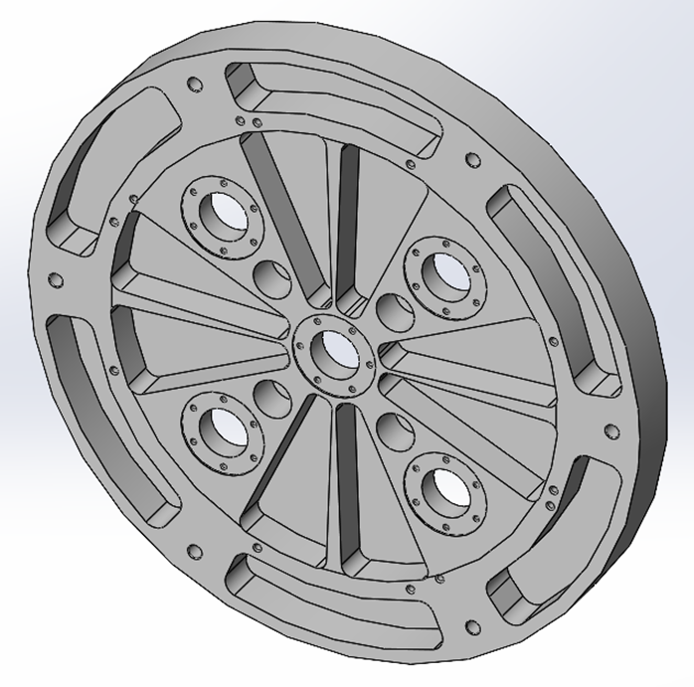

Fig. 5 - Rear Seal Plate

The snoot fixture involved a simpler implementation than the seal plates. The function of the snoot fixture is to stabilize the snoots, as well as provide the ability for slight adjustments. This will be done by fixing a solid base to the existing frame at NPOI, while having a plate that the snoots will be fixed to, that will be able to move in all the required directions. As of now, the material will be aluminum and will be hollowed out to make it lighter and more easily usable by the client. Fig 6 shows the current snoot fixture design.

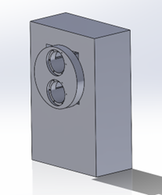

Fig. 6 - Snoot Adjusting Fixture

Throughout the semester, many adjustments were made to the design. A big lesson learned was that each design must be able to be easily and quickly adjusted for minor things. Some of the early stages of design were very complicated, which meant when something went wrong, the process of correcting the problem was long and arduous. The other key lesson was to update the client frequently, as we had designs that didn’t work, that needed to be adjusted to match their needs. The adjustments have all been small, so the design has not changed much since the beginning of the project.

## Implementation Plan

The primary mode of engineering calculations used for the plates was SolidWorks. In SolidWorks we were able simulate the amount of stress due to the vacuum on each plate. With the current designs, each had a deformation of less than .0010 in, which was the restriction set by the client. Figures 7 and 8 show the simulations.

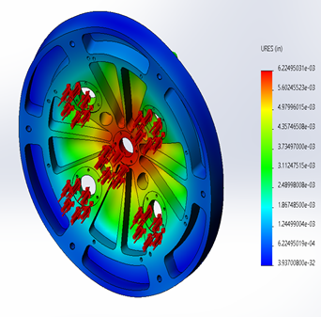

Fig. 7 - Front Seal Plate Deformation Simulation

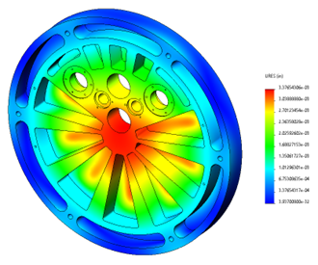

Fig. 8 - Rear Seal Plate Deformation Simulation

The snoot fixture does not require any calculations up to this point because it will not carry any critical load, and solely must provide stable adjustment. It will most certainly be able to hold the weight of the snoot.

Most of the raw material for this project has already been provided to us by NPOI. The current plan is to have the plates machined at NOFS and have the rest of the small parts by the end of the semester. After the plates have been externally machined, they will be assembled and implemented at NPOI. The snoot fixture raw materials will be ordered along with the other parts and will be machined in-house at NPOI. The full BOM and budget is included in Appendix B. There is no implementation cost because the new prototypes have been designed in such a way as to implement most of the procedures currently in use at NPOI. The schedule for the second semester is included in Appendix C.

Figure 9 shows the assembly and exploded view for the CAD model;

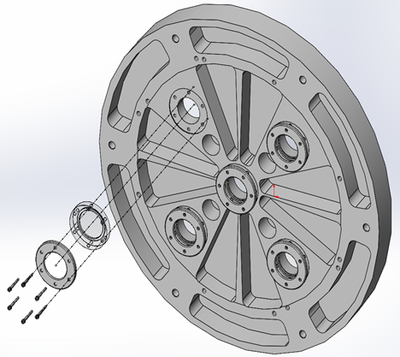

Fig. 9 - Assembly and Exploded View

# CONCLUSIONS

Over the course of Fast Delay Line (FDL) use, there is need for periodic maintenance within the vacuum tanks confining the FDL Carts. On the front of the FDL’s there are seal plates which capture snoots to relay the light in and out of the inner room. These seal plates and snoots use many features which take long lengths of time to disassemble and assemble. This issue is apparent on the front and rear of the tanks, although the rear seal plates do not have optical pass throughs. Reducing the use of large tools (gantry crane) and quantity of technicians needed to complete this task would be most beneficial to the Opto-Mechanical Group (OMG) at NPOI. The goal of this project is to streamline these procedures to make it faster and easier to perform maintenance on the FDL’s.

Some of the critical requirements of the project are weight, accessibility, holding vacuum, and being able to see into the FDL. Both of the seal plates will be made of 2-in thick aluminum with various respective features required for both of them. The snoot adjuster will also be made of aluminum allowing for strength and relative light weight. These designs will provide all the requirements for the client after production is completed

# REFERENCES

[1] 'The Importance of Choosing the Correct Material for Vacuum O-Rings and Vacuum Seals'. Apple Rubber.  [OnlineAccess]. <https://www.applerubber.com/hot-topics-for-engineers/the-importance-of-the-correct-material-for-vacuum-o-rings-and-vacuum-seals/>

[2] J.A. Clark III , J. Murphy, L. Ha, J. P. Walton , J. Howard, J. T. Armstrong, G. C. Gilbreath  , R. B. Hindsley , and T. A. Pauls. 'Alignment of vacuum feed stations on the Navy Prototype Optical Interferometer'. [OnlineAccess]. <https://apps.dtic.mil/sti/pdfs/ADA477246.pdf>

[3] 'Vacuum Chambers and Optical Equipment'. Imperial Machine & Tool CO. [OnlineAccess]. <https://www.imperialmachine.com/vacuum-chambers>

[4] 'The long-stroke MROI vacuum delay lines from concept to generation' [OnlineAccess]. <https://www.researchgate.net/publication/237371110_The_long-stroke_MROI_vacuum_delay_lines_from_concept_to_production>

[5] “Kurt J. Lesker Company,” *www.lesker.com*. <https://www.lesker.com/index.cfm> (accessed Oct. 11, 2022).

[6] “Parker Engineering Your Success Motion Control Technology,” *Parker Hannifin Corporation*, 2020. <https://www.parker.com/portal/site/PARKER/menuitem.b90576e27a4d71ae1bfcc510237ad1ca/?vgnextoid=c38888b5bd16e010VgnVCM1000000308a8c0RCRD&vgnextfmt=EN>

[7] “Fittings, Flanges, and Hardware | Ideal Vacuum,” *www.idealvac.com*. <https://www.idealvac.com/Fittings-and-Flanges/ct/2> (accessed Oct. 11, 2022).

[8] “Vacuum Fittings and Flanges,” *www.newport.com*. <https://www.newport.com/c/vacuum-flange-components> (accessed Oct. 11, 2022).

[9] “Optical Imaging | Laser Optics | Edmund Optics,” *www.edmundoptics.com*. <https://www.edmundoptics.com/>

[10] “Carr,” *McMaster*. [Online]. Available: <https://www.mcmaster.com/>. [Accessed: 11-Oct-2022].

[11] “Thorlabs, Inc. - your source for fiber optics, laser diodes, optical instrumentation and polarization measurement & control,” *Thorlabs, Inc. - Your Source for Fiber Optics, Laser Diodes, Optical Instrumentation and Polarization Measurement & Control*. [Online]. Available: <https://www.thorlabs.com/>. [Accessed: 11-Oct-2022].

[12] “Aluminum supplier,” *Aluminum Supplier | Bar, Sheet, Plate, Tube, Pipe, Shape*. [Online]. Available: <https://www.industrialmetalsupply.com/Products/Metals/aluminum?gclid=EAIaIQobChMIp7f_rKrZgIV9QetBh3t0QAOEAAYASAAEgKFvPD_BwE>. [Accessed: 11-Oct-2022].

[13] “Home,” *Alaska Rubber Group*. [Online]. Available: <https://www.alaskarubbergroup.com/>. [Accessed: 11-Oct-2022].

[14] [Www.htcvacuum.com](http://www.htcvacuum.com/) 日揚科技股份有限公司 |, “Vacuum components suppliers: Vacuum products manufacturer: Vacuum Chamber Kits - HTC Vacuum,” *Vacuum Components Suppliers| Vacuum Products Manufacturer | Vacuum Chamber kits - Htc vacuum*. [Online]. Available: <https://www.htcvacuum.com/en-global/vacuum-components?gclid=EAIaIQobChMIrKbp4arZ-gIV-BetBh3FDAJXEAAYASAAEgKxi_D_BwE>. [Accessed: 11-Oct-2022].

[15] “Socket Head Cap Screws Dimensions & Specs | AFT Fasteners,” [*www.aftfasteners.com*](http://www.aftfasteners.com/). <https://www.aftfasteners.com/socket-cap-screws-dimensions-and-mechanical-properties/> (accessed Oct. 11, 2022).

[16] *Light Weight Design Without Compromising Design for Manufacturing.* www.custiv.com/blog/systems-level-weight-reduction. Accessed 23 Oct. 2022.

[17] “How to Evaluate Materials – Properties to Consider.” *MetalTek*, 23 Aug. 2022, [www.metaltek.com/blog/how-to-evaluate-materials-properties-to-consider](http://www.metaltek.com/blog/how-to-evaluate-materials-properties-to-consider).

[18] Al-Samman, Talal. *Material and Process Design for Lightweight Structures*. MDPI AG, 2019.

[19] “Aluminum Vacuum Chambers.” Atlas Technologies, 10 May 2021, www.atlasuhv.com/products/vacuum-chambers/aluminum-vacuum-chambers.

[20] “Sealing Options for Aluminum Vacuum Chambers.” Meyer Tool & Mfg., www.mtm-inc.com/sealing-options-for-aluminum-vacuum-chambers1.html. Accessed 23 Oct. 2022.

[21] “Sharon Vacuum Custom Chamber - Vacuum Systems.” *BMI Surplus*, 14 Sept. 2021, bmisurplus.com/product/sharon-vacuum-custom-chamber.

[22] Apex Vacuum. “Sharon Vacuum Chambers.” *Apex Vacuum*, 12 Aug. 2020, apexvacuum.com/sharon-vacuum-chambers.

[23] “Vacuum Viewports ” *Htc Vacuum*, www.htcvacuum.com/en-global/vacuum-components/vacuum-viewport/sapphire-viewport. Accessed 23 Oct. 2022.

[24] *Flexible Pipe Bellows | McMaster-Carr*. www.mcmaster.com/flexible-pipe-bellows. Accessed 23 Oct. 2022.

[25] Components, M. “Metal Bellows.” *MW Components*, 18 Aug. 2022, www.mwcomponents.com/metal-bellows.

[26] “---.” Meyer Tool & Mfg., www.mtm-inc.com/sealing-options-for-aluminum-vacuum-chambers1.html. Accessed 23 Oct. 2022.

[27] LJ Star Incorporated. “Sight Glasses, Windows, and View Ports | Find Your Perfect Model.” LJ Star, 19 Aug. 2022, www.ljstar.com/product-lines/sight-glasses.

# APPENDICES

## Appendix A: FMEA

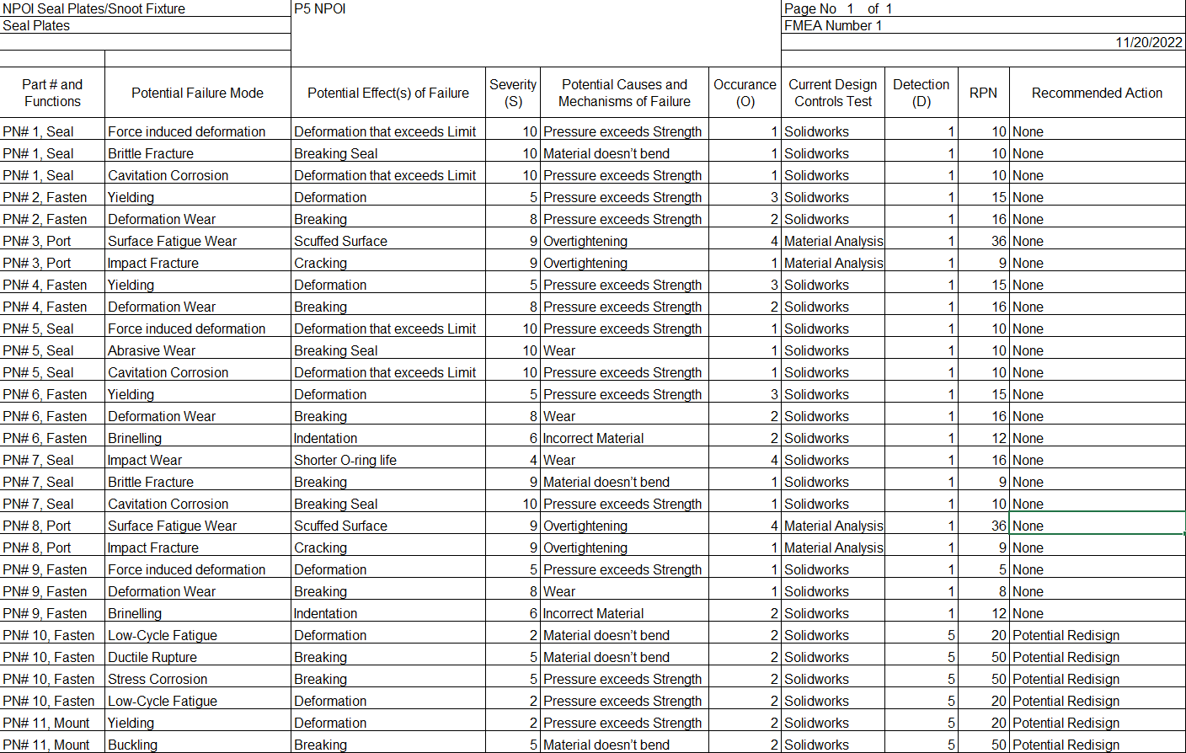

## Appendix B: BOM and Budget

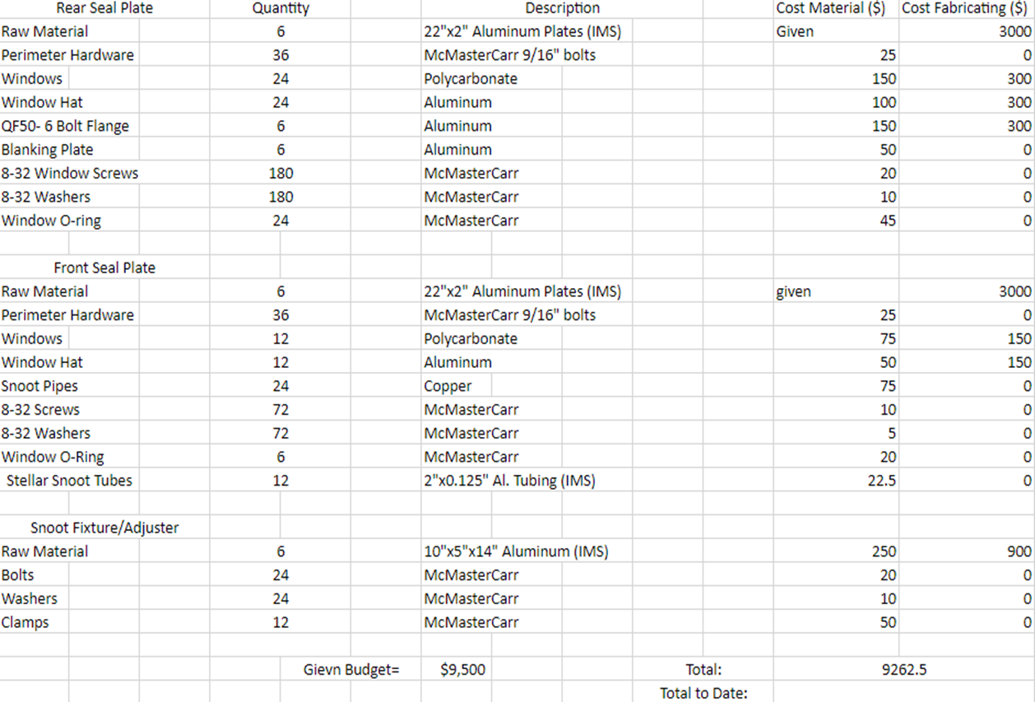

## Appendix C: Schedule for Second Semester (Gantt Chart)

